**CHAPTER 1: THEORETICAL BACKGROUND AND LITERATURE REVIEW**

This chapter explores the theoretical foundations and prior research relevant to AI-driven quiz generation and multimedia learning tools. It begins with an overview of artificial intelligence and its role in processing multimodal content, followed by the process of AI-generated quiz creation. The chapter then reviews AI-powered multimedia generation models—ranging from text-to-text, text-to-image, text-to-audio, and text-to-video—and their applications in education. Finally, it examines existing AI quiz-generation tools, their functionalities, challenges, and emerging trends, providing a basis for understanding how this project builds upon and extends current technologies.

**1. Artificial Intelligence (AI) Overview**

The field of artificial intelligence (AI) is concerned with building machines that are able to carry out operations like perception, reasoning, and decision-making that normally call for human intelligence. Rule-based systems gave way to data-driven machine learning in modern AI, with large-scale deep learning models—particularly transformers—being the driving force behind recent advances. These days, large language models (LLMs) like GPT (OpenAI, 2025), Llama (Meta AI, 2024), Claude (Anthropic, 2024), and Gemini (Google DeepMind, 2024) serve as flexible reasoning engines that can process multimodal inputs, text, and code.

By processing text, audio, images, and video in a single pipeline, multimodal AI expands these capabilities (Yin et al., 2024) even further, opening the door for uses like lecture transcription and analysis. While parameter-efficient fine-tuning techniques (e.g., LoRA) enable cost-effective customization (Hu et al., 2022) for domain-specific tasks, retrieval-augmented generation (RAG) techniques increase accuracy (Lewis et al., 2020) by connecting models to external knowledge sources. Strong text-to-image, audio, and video models are another example of generative AI advancements that increase the creative and analytical potential.

AI is better able to handle big, complicated datasets, like complete lecture transcripts, when it has longer context windows and uses agent-like tools. In addition to these capabilities, safety, alignment, and governance frameworks are becoming more and more important in order to ensure responsible deployment, particularly in delicate areas like education.

**2. AI-Generated Quiz Creation Process**

A multi-step process that combines knowledge comprehension, question formulation, and content extraction is used to create AI-generated quizzes. The system starts by ingesting source material, such as documents, audio recordings, videos, or lecture transcripts. Automatic speech recognition (ASR) transforms audio into text for non-text inputs, and optical character recognition (OCR) pulls text from slides or pictures.

Natural language processing (NLP) is applied to the extracted text in order to pinpoint important ideas, connections, and learning goals. Retrieval-augmented generation (RAG) guarantees that questions generated are based on the original content, while summarization models distill extensive content into targeted sections. These concepts are converted into multiple-choice, fill-in-the-blank, true/false, and short answer question formats by large language models (LLMs) like GPT or LLaMA, which are frequently refined using educational datasets.

Based on student performance data or frameworks such as Bloom's Taxonomy, dynamic difficulty adaptation is feasible. These capabilities are demonstrated by platforms that support multimodal inputs and customizable outputs, like Questgen AI (2025), Quizbot AI, and VidVersityQG (Shahid, Hussain, & Shoaib, 2021). This procedure is a useful tool in contemporary education since it not only automates the creation of assessments but also customizes tests for focused revision.

**3. AI Multimedia Generating Tools**

**3.1 Overview**

Artificial intelligence systems created to automate or support the production of different media types, such as text, images, audio, video, animation, and interactive content, are referred to as AI multimedia tools.

In order to produce richer and more captivating user experiences, multimedia generally integrates various types of content—such as text, images, audio, and video—into a single presentation. Through features like games, quizzes, and clickable elements, interactive multimedia makes content more dynamic and personalized while encouraging active user participation.

The creation of content has changed dramatically as a result of AI developments. AI can create organized and cohesive textual content, including blog posts, reports, and articles, thanks to Natural Language Processing (NLP). While AI-powered tools support music composition, sound editing, voice synthesis, video production, and animation, Generative Adversarial Networks (GANs) and other generative models help create realistic images. When taken as a whole, these innovations facilitate customized multimedia experiences, improve creative efficiency, and lessen manual labor.

*Reference: Wikipedia, Multimedia; AIPLUSINFO, AI’s Influence on Media and Content Creation*

**3.2 Text-to-Text Generation Models**

The creation of content has changed dramatically as a result of AI developments. AI can create organized and cohesive textual content, including blog posts, reports, and articles, thanks to Natural Language Processing (NLP). While AI-powered tools support music composition, sound editing, voice synthesis, video production, and animation, Generative Adversarial Networks (GANs) and other generative models help create realistic images. When taken as a whole, these innovations facilitate customized multimedia experiences, improve creative efficiency, and lessen manual labor.

Institutions should create adaptable policies, train employees and students on moral AI use, and rethink tests to prevent abuse in order to meet these challenges. In order to identify AI-generated content, human judgment is still essential. In the AI era, preserving academic integrity requires involving students in policy-making and implementing a cooperative community approach.

**3.3 Text-to-Image Models**

AI programs that can produce images straight from descriptions in natural language are called text-to-image models. They allow users to create visuals that correspond with particular prompts by bridging the gap between linguistic and visual modalities.

**Current methods consist of:**

1. **GAN-based Models:** Using a generator–discriminator framework, Generative Adversarial Networks generate realistic images that correspond with text descriptions.
2. **Diffusion Models:** Stable Diffusion and DALL·E 2 gradually convert noise into coherent images through prompt-guided denoising steps.
3. **Transformer-based Models:** Use transformer architectures to model the relationships between text and visual elements for fine-grained image control.
4. **Hybrid Approaches:** Utilize a variety of methods to optimize semantic accuracy and visual quality.

**Applications:** Digital art, marketing, product design, and instructional content production.

**3.4 Text-to-Audio/Voice Models**

Applications such as voice assistants, audiobooks, and music composition are made possible by these AI systems, which use text as input to produce speech, music, or sound effects. Examples include **Uber’s Jukebox** and **Google WaveNet**.

**3.5 Text-to-Video Models**

New AI technologies automate video production processes by producing video content from minimal inputs or text descriptions. While still in the early stages of development, platforms such as **Google’s VEO 3**, **Meta’s Make-A-Video**, and **Runway Gen-2** show promise.

**3.6 Use Cases in Education**

By creating rich, context-specific visual materials that are suited to different learning styles, text-to-image models can improve education by increasing engagement and comprehension (Chen & Wang, 2022).

* Less manual design is required because teachers can produce original diagrams, infographics, and illustrations aligned with lesson goals.
* Students can visualize historical occurrences, scientific procedures, and abstract ideas to improve memory and creativity.
* These resources can be incorporated into courses in creative fields like media studies, design, and art.
* Inclusive education benefits from accessible and culturally appropriate imagery for diverse linguistic contexts and students with disabilities.

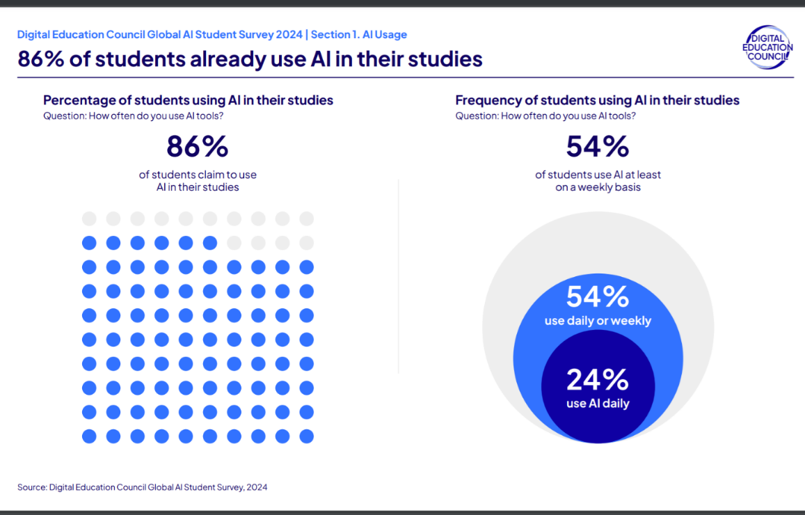

**Figure 1.** Student AI Usage Statistics. Adapted from *Digital Education Council Global AI Student Survey* (2024).

- 86% of students already use AI in their studies.

- 54% use AI daily or weekly, with 24% using it daily.

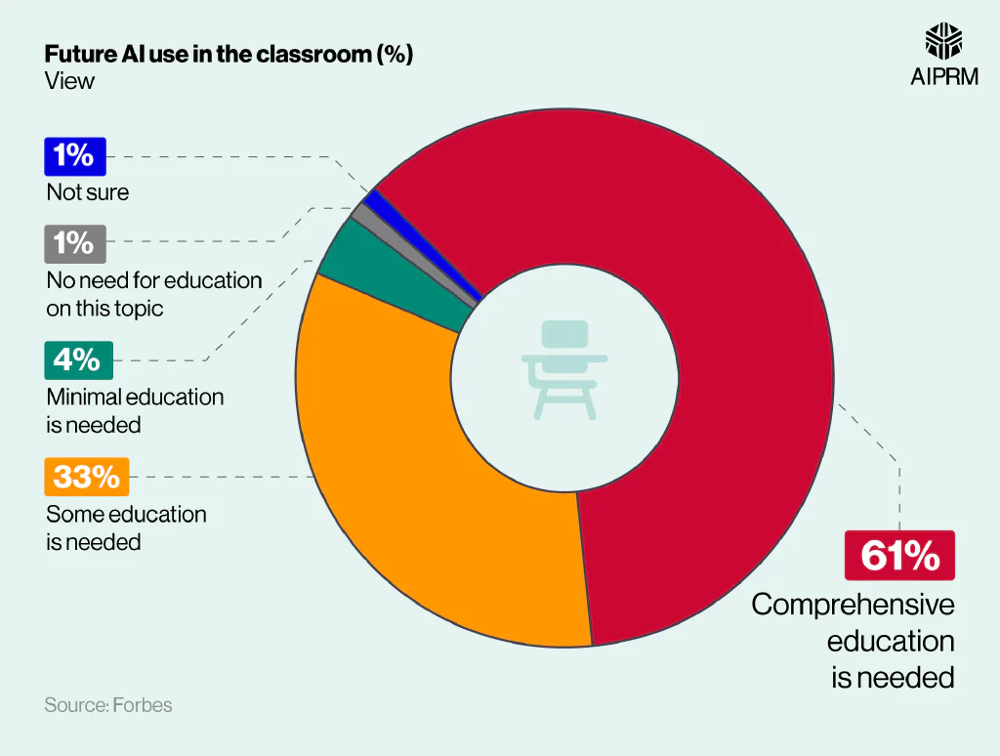

**Figure 2.** Student AI Usage Statistics. Adapted from *Digital Education Council Global AI Student Survey* (2024).  
Note: 86% of students use AI in their studies; 54% use AI daily or weekly, with 24% using it daily.

**3.7 Challenges and Ethics**

Even though AI multimedia tools have a lot of potential, their responsible use requires addressing key challenges:

* **Content Quality & Reliability:** AI may generate biased, erroneous, or misleading results.
* **Bias & Fairness:** Training data can reinforce stereotypes, affecting inclusivity.
* **Intellectual Property & Copyright:** AI may unintentionally replicate existing works.
* **Misinformation Risks:** Misuse for deepfakes or fake news undermines trust.
* **Privacy & Data Protection:** Sensitive data use raises ethical and legal concerns.

**Solution:** Collaboration among technologists, educators, policymakers, and ethicists is needed to ensure accountability, transparency, and fairness.

**4. AI Tools to Generate Quizzes**

**4.1 Introduction**

*By making it possible to create quizzes automatically, the development of artificial intelligence (AI) has drastically changed educational assessment. Natural language processing (NLP) and machine learning (ML) algorithms are used by AI-driven quiz generation tools to produce a variety of assessments that can be customized to meet the needs of each learner. These resources have the potential to support adaptive learning environments, increase instructional efficiency, and offer instant feedback (Alsmadi & Almarashdeh, 2023). The basic processes underlying AI quiz creation, the range of question types generated, and the main advantages, difficulties, and restrictions related to their use in education are all covered in this section.*

**4.2 How AI Quiz Tools Work**

*AI quiz generation systems employ a combination of Natural Language Processing (NLP), Machine Learning (ML), and large language models (LLMs), such as GPT, to automatically generate questions from educational materials. NLP techniques allow systems to parse text, discover, and extract concepts, as well as to discern relationships between concepts and ideas. ML algorithms allow systems to identify existing patterns in question banks and learner performance data, and to formulate more contextualized and accurately structured questions. More advanced systems can include large language models that can actually create a new piece of content, paraphrase a complex idea, and be able to change the complexity of the language to an appropriate level for the audience. Most systems can accept a range of formats—like documents, lecture transcripts, or video—and produce diverse question formats, such as multiple-choice, true/false, open-ended, and scenario-based items. Finally, the system usually produces a validation step to ensure pre-generated questions meet learning objectives and standards for clarity and accuracy before being distributed for final delivery.*

**4.3 Types of Questions Generated**

*Artificial intelligence quiz tools generate many types of questions, and their benefits are specific to their academic purpose. Multiple-choice questions (MCQs) are the most common format - students demonstrate recognition and recall by choosing from several answering options and only one correct answer to complete the task. True/False questions are valuable when quickly assessing binary knowledge statements, as they allow the user to collect many responses to evaluate factual understanding quickly. Short-answer responses allow for a gravitational active recall process as students generate short responses. More advanced AI systems allow for open-ended or essay-style questions that can assess higher-level thinking skills such as critical thinking, synthesis, and application. Because AI quiz tools can generate many question types, they can provide a range of assessment strategies to assess different learning styles and objectives.*

**4.4 Personalization and Adaptivity**

*Although there have been some good examples of progress, the vast majority of tools for AI quiz generation today, provide little to no genuine personalization/adaptivity. Most often, these tools provide static quizzes which do not change the difficulty of questions or change topic depending on learner performance or preferences. Similarly, feedback systems are basic, and offer little if any, meaningful suggestions to assist the learner in their progression. These various forms of lack of adaptivity, means learners are having generic learning experiences that take advantage of the limited personalization/adaptiveness, thus also limiting the overall utility and engagement with educational opportunities.*

**4.5 Challenges and Limitations**

*AI quiz tools are capable of generating questions only too easily, but a consistent challenge is generating coherent and context-related choice options. These tools, including Quizlet, Quizziz, Kahoot, QuestionPro, and ProProfs, often produce distractors that are completely unrelated to the question stem, i.e., a question that pertains to a date, has distractors that include ocean names or phrases that are unrelated (Observations, 2025). This is not only a misuse of an assessment tool, but it also detracts from the overall validity of the assessment. Also, many tools limit the characters of the questions and answer options, which limits their complexity and clarity. The inability to scale question difficulty is also widespread, limiting tools' ability to be effective for learners of multiple abilities. Overall, these issues result in poor quality, reliability, and use in the teaching/learning process of AI-created quizzes (Observations, 2025).*

**4.6 Future Trends**

*The rising use of advanced large language models (LLMs) like GPT, Gemini, and related technologies is one of the most exciting developments in AI quiz generation. When compared to traditional quiz methods, LLMs can produce better quality quiz questions, and aspects of difficultly will be contextualized, which allows for more personalized learning opportunities. However, the LLM strength still produces quizzes in a relatively static/non-interactive way, as the AI-generated quiz still provides limited real-time adaptivity when creating quizzes that are intended to engage the learner and give them dynamic real-time feedback. Future research and development of LLMs are likely to focus on integration with interactive platforms for assessment, to allow for a more adaptive experience, producing courses that are more immersive and responsive to students needs.*

**References**

OpenAI. (2025). *Introducing GPT-5*. <https://openai.com>

Meta AI. (2024). *Llama 3 models*. <https://ai.meta.com/llama>

Google DeepMind. (2024). *Gemini 1.5 announcement*. <https://deepmind.google>

Anthropic. (2024). *Claude 3 family*. <https://www.anthropic.com>

Yin, W., et al. (2024). *A survey on multimodal large language models*. <https://arxiv.org/abs/2401.13601>

Lewis, P., et al. (2020). *Retrieval-augmented generation for knowledge-intensive NLP*. <https://arxiv.org/abs/2005.11401>

Hu, E., et al. (2022). *LoRA: Low-rank adaptation of large language models*. <https://arxiv.org/abs/2106.09685>

Questgen AI. (2025). *AI-powered question generation platform*. <https://www.questgen.ai>

Quizbot AI. (2025). *Automated quiz creation tool*. <https://quizbot.ai>

Shahid, O., Hussain, S., & Shoaib, M. (2021). *VidVersityQG: Automated video-based question generation for education*. <https://arxiv.org/abs/2112.01229>

Quizaic. (2025). *A generative AI case study*. Medium. <https://medium.com/google-cloud/quizaic-a-generative-ai-case-study-190b02baa8df>

ChatGPT. (2025). *OpenAI language model responses and related documentation*. OpenAI.

Observations. (2025). *Quizlet, Quizziz, Kahoot, QuestionPro, and ProProfs platforms*.

Alsmadi, I., & Almarashdeh, I. (2023). Artificial intelligence applications in education: A review of current trends and future perspectives. *Education and Information Technologies, 28*(4), 4513–4532. <https://doi.org/10.1007/s10639-022-11298-4>

Chen, Y., & Wang, X. (2022). Enhancing learning engagement through AI-assisted content creation. *Computers & Education, 181*, 104453. <https://doi.org/10.1016/j.compedu.2022.104453>

Kovačević, A., & Li, J. (2023). The role of generative AI in personalized education. *British Journal of Educational Technology, 54*(5), 1290–1307. <https://doi.org/10.1111/bjet.13315>

Zhang, M., & Lee, D. (2021). Artificial intelligence for multimedia-based education: Opportunities and challenges. *Interactive Learning Environments, 29*(7), 1132–1149. <https://doi.org/10.1080/10494820.2019.1703012>

UNESCO. (2023). *Guidance on the ethical use of artificial intelligence in education*. Paris: UNESCO Publishing. <https://unesdoc.unesco.org>

Hao, K. (2019, January 21). AI is sending people to jail—and getting it wrong. *MIT Technology Review*. <https://www.technologyreview.com/2019/01/21/137783/ai-is-sending-people-to-jail-and-getting-it-wrong>